
Programming fundamentals
Project Report


Program: Tic Tac Toe Game

Student’s Name: ABDUL
Student ID:
Section: I-C
Dept: Computer Science
Instructor:
Date:



SINDH-MADRESSATUL-ISLAM-UNIVERSITY

THIS IS CERTIFIED THAT

ABDUL RAFEH

Students of BS (Computer Science) has successfully completed 1st Semester project on TIC TAC TOE game using c language in year 2020 under the guidance of

PROFESSOR
Signature:

TIC-TAC-TOE GAME

Introduction: ic-tac-toe is not a very challenging game for human beings. If you’re an enthusiast, you’ve
probably moved from the basic game to some variant like three dimensional tic-tac-toe on
a larger grid. If you sit down right now to play ordinary three-by-three tic-tac-toe with a friend,
what will probably happen is that every game will come out a tie. Both you and your friend
can probably play perfectly, never making a mistake that would allow your opponent to win. But
can you describe how you know where to move each turn? Most of the time, you probably aren’t
even aware of alternative possibilities; you just look at the board and instantly know where you
want to move. That kind of instant knowledge is great for human beings, because it makes you a
fast player.
But it isn’t much help in writing a computer program. For that, you have to know very explicitly
what your strategy is.
Tic-tac-toe is a casual strategy game for everyone. It is easy to teach, and the player can play this
game almost everywhere. Because it only requires a writing tool and a writable surface.
Vandalism is not recommended
ic-tac-toe is not a very challenging game for human beings. If you’re an enthusiast, you’ve
probably moved from the basic game to some variant like three dimensional tic-tac-toe on
a larger grid. If you sit down right now to play ordinary three-by-three tic-tac-toe with a friend,
what will probably happen is that every game will come out a tie. Both you and your friend
can probably play perfectly, never making a mistake that would allow your opponent to win. But
can you describe how you know where to move each turn? Most of the time, you probably aren’t
even aware of alternative possibilities; you just look at the board and instantly know where you
want to move. That kind of instant knowledge is great for human beings, because it makes you a
fast player.
But it isn’t much help in writing a computer program. For that, you have to know very explicitly
what your strategy is.
Tic-tac-toe is a casual strategy game for everyone. It is easy to teach, and the player can play this
game almost everywhere. Because it only requires a writing tool and a writable surface.
Vandalism is not recommended
ic-tac-toe is not a very challenging game for human beings. If you’re an enthusiast, you’ve
probably moved from the basic game to some variant like three dimensional tic-tac-toe on
a larger grid. If you sit down right now to play ordinary three-by-three tic-tac-toe with a friend,
what will probably happen is that every game will come out a tie. Both you and your friend
can probably play perfectly, never making a mistake that would allow your opponent to win. But
can you describe how you know where to move each turn? Most of the time, you probably aren’t
even aware of alternative possibilities; you just look at the board and instantly know where you
want to move. That kind of instant knowledge is great for human beings, because it makes you a
fast player.
But it isn’t much help in writing a computer program. For that, you have to know very explicitly
what your strategy is.
Tic-tac-toe is a casual strategy game for everyone. It is easy to teach, and the player can play this
game almost everywhere. Because it only requires a writing tool and a writable surface.
Vandalism is not recommended
ic-tac-toe is not a very challenging game for human beings. If you’re an enthusiast, you’ve
probably moved from the basic game to some variant like three dimensional tic-tac-toe on
a larger grid. If you sit down right now to play ordinary three-by-three tic-tac-toe with a friend,
what will probably happen is that every game will come out a tie. Both you and your friend
can probably play perfectly, never making a mistake that would allow your opponent to win. But
can you describe how you know where to move each turn? Most of the time, you probably aren’t
even aware of alternative possibilities; you just look at the board and instantly know where you
want to move. That kind of instant knowledge is great for human beings, because it makes you a
fast player.
But it isn’t much help in writing a computer program. For that, you have to know very explicitly
what your strategy is.
Tic-tac-toe is a casual strategy game for everyone. It is easy to teach, and the player can play this
game almost everywhere. Because it only requires a writing tool and a writable surface.
Vandalism is not recommended
ic-tac-toe is not a very challenging game for human beings. If you’re an enthusiast, you’ve
probably moved from the basic game to some variant like three dimensional tic-tac-toe on
a larger grid. If you sit down right now to play ordinary three-by-three tic-tac-toe with a friend,
what will probably happen is that every game will come out a tie. Both you and your friend
can probably play perfectly, never making a mistake that would allow your opponent to win. But
can you describe how you know where to move each turn? Most of the time, you probably aren’t
even aware of alternative possibilities; you just look at the board and instantly know where you
want to move. That kind of instant knowledge is great for human beings, because it makes you a
fast player.
But it isn’t much help in writing a computer program. For that, you have to know very explicitly
what your strategy is.
Tic-tac-toe is a casual strategy game for everyone. It is easy to teach, and the player can play this
game almost everywhere. Because it only requires a writing tool and a writable surface.
Vandalism is not recommended
Introduction: Tic-tac-toe (also known as noughts and crosses or X and O) is a paper-and-pencil game for two players, X and O, who take turns marking the spaces in a 3×3 grid. The player who succeeds in placing three of their marks in a horizontal, vertical, or diagonal row wins the game. Tic-tac-toe is not a very challenging game for human beings. what will probably happen is that every game will come out a tie. Both you and your friend can probably play perfectly, never making a mistake that would allow your opponent to win.
what will probably happen is that every game will come out a tie. Both you and your friend can probably play perfectly, never making a mistake that would allow your opponent to win.
Rules of the Game:
• The game is to be played between two people (in this program between Player 1 and Player 2).

• One of the players chooses ‘X’ and the other ‘O’ to mark their respective cells.
• The game starts with player 1 and the game ends when one of the players has one whole row/ column/ diagonal filled with respective character (‘X’ or ‘O’).
A player can play perfect tic-tac-toe (win or draw) given they move according to the highest possible move from the following table.
- Win: If the player has two in a row, play the third to get three in a row.
- Block: If the opponent has two in a row, play the third to block them.
- Fork: Create an opportunity where you can win in two ways.
- Center: Play the center.
Implementation:
- Start from Player 1.
- Then each player taking turn draw their symbol on a space from that nine possible spaces.
- The one who met the winning condition first win. If after nine possible spaces are
used, but no one wins, that game is a draw.

Winning Condition:
These are the acceptable win condition of this game
Winning Condition:
These are the acceptable win condition of this game

Learning Game: This classic game contributes to children's developmental growth in numerous ways including their understanding of predictability, problem solving, spatial reasoning, hand-eye coordination, turn taking, and strategizing.

Function use in Project Code:
We mainly used these functions in this project code which are define in below points:

- In this project we used the graphics function which are “Background color, line, circle” & with help of these graphics function we present our project.
- In this project we also used gotoxy function for the positioning the objects/text on the screen.
- We used printf function for printing the (Character, integer & values) on the output screen.
- We used also for loop function in project for showing the player’s turns.
- We used if function in project for putting the player’s sign in the game, shows the result of the game & also for player’s want to quit or continue the game.

Project Code:
#include<graphics.h>
#include<stdio.h>
#include <conio.h>
void main()
{
int driver=DETECT,mode;

int a[3][3]={5,6,7,8,9,10,11,12,13},i,j,k,x,y,t,cn=0,co=0;
char c;
static int nod=0,nn=0,sc[2]={0,0};
nod++;
clrscr();

initgraph(&driver,&mode,"c:\\TURBOC3\\BGI");
setbkcolor(BLUE);
line(100,200,400,200);
line(100,300,400,300);

line(200,100,200,400);
line(300,100,300,400);
gotoxy(35,2);
printf("TIC TAC TOE");
gotoxy(20,3);
gotoxy(10,5);
printf(" BOX NO");
gotoxy(15,7);
printf("1");
gotoxy(30,7);
printf("2");
gotoxy(45,7);
printf("3");
gotoxy(15,14);
printf("4");
gotoxy(30,14);
printf("5");
gotoxy(45,14);
printf("6");
gotoxy(15,21);
printf("7");
gotoxy(30,21);
printf("8");
gotoxy(45,21);
printf("9");
gotoxy(55,22);
printf("RESULT");
gotoxy(55,23);
printf("****************");
gotoxy(55,15);
printf("P1-ABDUL RAFEH",sc[0]);
gotoxy(55,16);
printf("P2-WAQAR ALI",sc[1]);
for(i=0;i<=2;i++)
{
for(j=0;j<=2;j++)
{
re:gotoxy(65,4);
k=((i+j)%2+1);
printf("Enter player %d",k);
gotoxy(60,5);
printf(" Box no from 1 to 9 ");
t=getch();
t=t-48;
if(t==1)
{
x=0;y=0;
goto play;
}
if(t==2)
{
x=1;y=0;
goto play;
}
if(t==3)
{
x=2;y=0;
goto play;
}
if(t==4)
{
x=0;y=1;
goto play;
}
if(t==5)
{
x=1;y=1;
goto play;
}
if(t==6)
{
x=2;y=1;
goto play;
}
if(t==7)
{
x=0;y=2;
goto play;
}
if(t==8)
{
x=1;y=2;
goto play;
}
if(t==9)
{
x=2;y=2;
goto play;
}
else
{
goto re ;}
play:
if((a[x][y]==1)||(a[x][y]==2))
{
goto re;
}
if((a[x][y]!=1)&&(a[x][y]!=2))
{
if(k==1)
{
circle(100*x+100+50,100*y+100+50,50);
a[x][y]=k;co++;
}
if(k==2)
{
line(x*100+100,y*100+100,x*100+200,y*100+200);
line(x*100+100,y*100+200,x*100+200,y*100+100);
a[x][y]=k;co++;
}
}
gotoxy(60,23);
if((a[0][0]==a[1][0])&&(a[1][0]==a[2][0]))
{
printf("Player %d",k);
printf(" wins");cn=1;sc[k-1]++;
}
if((a[0][0]==a[0][1])&&(a[0][1]==a[0][2]))
{
printf("Player %d",k);
printf(" wins");cn=1;sc[k-1]++;
}
if((a[0][0]==a[1][1])&&(a[1][1]==a[2][2]))
{
printf("Player %d",k);
printf(" wins");cn=1;sc[k-1]++;
}
if((a[1][0]==a[1][1])&&(a[1][1]==a[1][2]))
{
printf("Player %d",k);
printf(" wins");cn=1;sc[k-1]++;
}
if((a[2][0]==a[2][1])&&(a[2][1]==a[2][2]))
{
printf("Player %d",k);
printf(" wins");cn=1;sc[k-1]++;
}
if((a[2][0]==a[1][1])&&(a[1][1]==a[0][2]))
{
printf("Player %d",k);
printf(" wins");cn=1;sc[k-1]++;
}
if((a[0][2]==a[1][2])&&(a[1][2]==a[2][2]))
{
printf("Player %d",k);
printf(" wins");cn=1;sc[k-1]++;
}
if((a[0][1]==a[1][1])&&(a[1][1]==a[2][1]))
{
printf("Player %d",k);
printf(" wins");cn=1;sc[k-1]++;
}
if(cn==1)
{
goto que;}
if(co==9)
{
gotoxy(62,23);
printf("DRAW");
nn++;
goto que;}
}
}
que:
gotoxy(60,24);
printf("Play again y/n");
c=getch();
if((c=='y')||(c=='Y'))
{
clrscr();
main();
getch();
}
else if((c=='n')||(c=='N'))
{
goto end;
}
else goto que;

end:
closegraph();
printf("Final score is %d",sc[k-1]);
printf(" - %d",nod-nn-sc[k-1]);
gotoxy(20,10);
printf("Thanks for playing this game\n");
gotoxy(20,11);
printf("Developed by ABDUL RAFEH & WAQAR ALI");
getch();
exit(0);

}

Output:
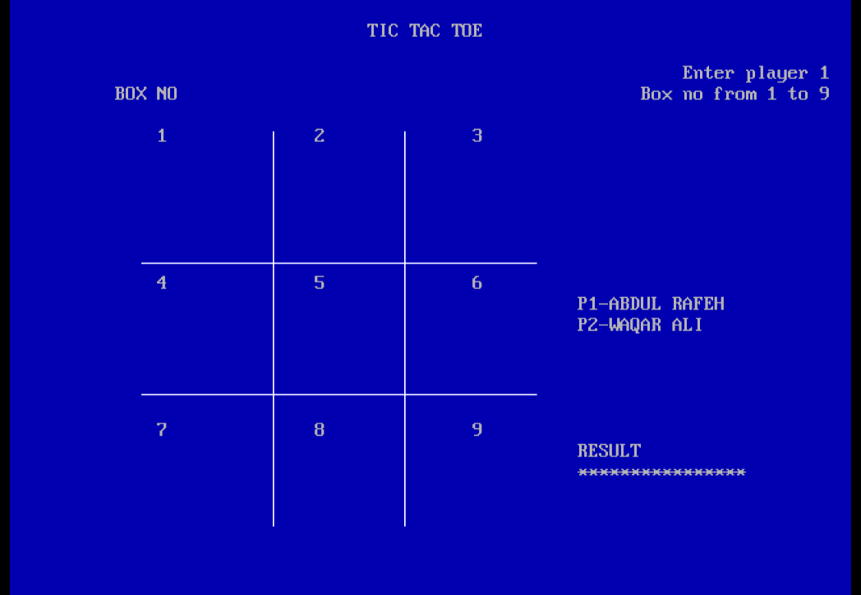

IDE:
- Turbo C++

